**IDS 1380 Intro to STEM Fall 2021**

**Mini-Project #3 Project Worksheet**

**Due** in Canvas, Sunday, Nov. 14, 2021 by 11:59 PM

Use matrices and techniques with the inverse matrix and ‘left division’ to solve system of equations that model a variety of systems in STEM applications. Mini-project #3 builds on basic MATLAB skills, including ‘calculator’ type functions, m-files, and simple input/output explored in Mini-Project #1. Each student is responsible for completion their own **Project Worksheet,** and in this effort, collaboration occurs within *new* and different P**3F groups** for insight, feedback, and minor assistance in MATLAB.

**What is a matrix in MATLAB?**

A matrix is a two-dimensional array of numbers. MATLAB is ‘matrix laboratory’ and uses matrices to easily solve systems of linear equations, especially helpful when there are more than 2 equations and 2 unknowns. Using a strict format for the original equations, they can be rewritten in matrix form, AX=B, and coded into MATLAB to solve for X with either X = inv(A)*B or X=A\B. In this application, MATLAB saves a tremendous amount of time and effort over hand calculations!

**Mini-Project #3 Lecture notes** – provides detailed instructions to complete this Project Worksheet and use the matrices and techniques to solve systems of equations in the MATLAB software

**Mini-project activities – 5 parts & Deliverables**

* 1- **Matrix Manipulation Skills** : Working with matrices in MATLAB – Syntax and operations
* 2- **Practice Matrix Multiplication with MATLAB** - matrices & multiplication
* 3- **Systems of Equations** – formulas only with inverse (inv) and left division ‘\’
* 4- **STEM Application – electrical circuits** 
  + Hand example from text similar to HW problem
  + Example using MATLAB
  + Use MATLAB example to create MATLAB code for your HW problem
  + MATLAB code expanded on example using MATLAB
* 5- **STEM Application –Mechanical System – Truss**
  + Hand example from text similar to HW problem
  + Example using MATLAB
  + Use MATLAB example to create MATLAB code for your HW problem
  + MATLAB code expanded on example using MATLAB

**Collaboration : Work in Peer Partnerships For Programming Feedback, P3F**

* 1. Collaborate in groups of 3 to help each other with programming issues, syntax checks, etc., as needed. *NEW* groups randomly assigned through Canvas. A brief reflection of **P3F** group ‘collaboration’ activities is required.
  2. **🡪 Format Instructions**: Each Part has instructions on the required format of your answer. All answers will be presented in a separate file, (not in between the questions in this worksheet.)

**DELIVERABLES for the Mini-project #3 Project Worksheet**

**Part 1. Matrix Manipulation Skills: Working with matrices in MATLAB – Syntax and operations 10 points**

After reviewing this lecture, complete the following questions using MATLAB. For every question, wrote the MATLAB code ‘copy & paste’ your MATLAB commands & ‘ans’ (answer.)

**🡪 Format Instructions**: On 1 or 2 pages (Page 1-2), include the following.

* Heading at top of page🡪 **Part 1. Practice ‘Matrix Manipulation Skills’ examples: Matrices - your name**
* **Type question number & letter, if applicable–** For example: **Part 1. #1 -a**
* Copy & paste (or snip/screenshot) your MATLAB code and results per 2) above.
  + Be sure it is clear & readable by the instructor.
* Add any comments below the code.

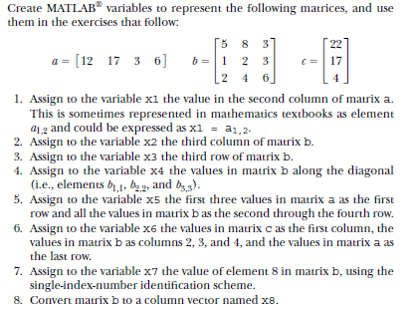

**Part 2. Practice: Matrix Multiplication with MATLAB 10 points**

Refer to example in lecture notes and compete part 2.

**🡪 Format Instructions**: On 1 or 2 pages (Page 2-3), include the following.

* Heading at top of page🡪 **Part 2. Practice ‘Matrix Manipulation 2 Skills’ examples: Matrices_2 - your name**
* **Type question number & letter, if applicable–** For example: **Part 2. #2 -a…**
* Copy & paste (or snip/screenshot) your MATLAB code and results per 2) above.
  + Be sure it is clear & readable by the instructor.
* Add any comments below the code.

**Part 2i- a & b**

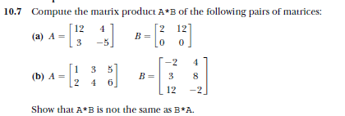

**Part 2 ii- (1-4)**

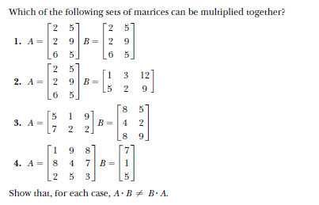

**Part 2 ii- (1-4)**

Given the array A = [-1 3; 4 2], compute the determinant of A both by hand and by using MATLAB.

**Part 3. Solving Systems of Linear Equations 10 pts**

Read this problem carefully. Write the MATLAB code and ‘copy & paste’ it here with your answer that appears in the command window. In this part of your Project Worksheet,

**🡪 Format Instructions**: On 1 or 2 pages (Page 4-5), include the following.

* Heading at top of page🡪 **Part 3. Practice ‘Systems of Linear Equations’ examples: Systems_of_equations- your name**
* **Type question number & letter, if applicable–** For example: **Part 3. #3 -a…**
* Copy & paste (or snip/screenshot) your MATLAB code and results per 2) above.
  + Be sure it is clear & readable by the instructor.
* Add any comments below the code.

**Part 3i- a & b**

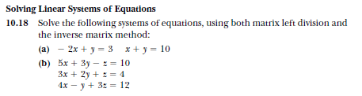

**Part 3ii.**

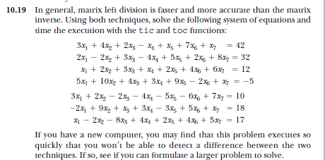

**Part 4. Intro to STEM application’ Problem -electrical circuits 30 points**

* + Hand example from text similar to HW problem
  + Example using MATLAB
  + Use MATLAB example to create MATLAB code for your HW problem
  + MATLAB code expanded on example using MATLAB

**🡪 Format Instructions**: On 1 or 2 pages (Page #), include the following.

* Heading at top of page🡪 **Part 4. Intro to STEM application’ Problem – electrical circuits - Your name**
* **Part 4a.** Hand write or type the problem done in in the Perfect Homework format
* **Part 4b, 4c, 4d.** Copy & paste (or snip/screenshot) your MATLAB code and results
  + Be sure it is clear & readable by the instructor.

Add any comments below the code.

Read this problem carefully.

In this part of your Project Worksheet,

1. Solve the problem using the 7 steps in Perfect Homework. Pay close attention to the units!

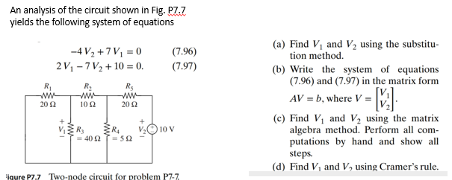

1. Follow the given example in the notes, type the MATLAB program paying close attention to the code because you will need in in the other parts of this problems. ‘Copy & paste’ or take a screen shoot/ picture of the Command Window with your new ‘modified’ MATLAB code and paste it here in this section. Note the ‘screen input’ for resistor values. **Write MATLAB code and run with 2 different sets of R values.**
2. 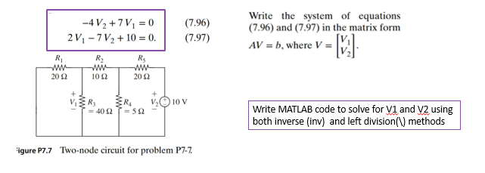**Use the MATLAB example to create MATLAB code for the problem in part A.** Copy & paste’ or take a screen shoot/ picture of the Command Window with your new ‘modified’ MATLAB code and paste it here in this section.
3. **Expand the problem on Part B with alternative approach. Write the MATLAB code and run with 2 different sets of R values.** Copy & paste’ or take a screen shoot/ picture of the Command Window with your new ‘modified’ MATLAB code and paste it here in this section.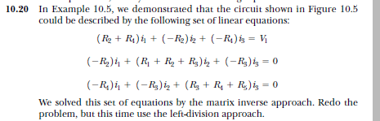

**Part 5. Intro to STEM application’ Problem -Mechanical Systems 30 points**

* + Hand example from text similar to HW problem
  + Example using MATLAB
  + Use MATLAB example to create MATLAB code for your HW problem
  + MATLAB code expanded on example using MATLAB

**🡪 Format Instructions**: On 1 or 2 pages (Page #), include the following.

* Heading at top of page🡪 **Part 5. Intro to STEM application’ Problem – mechanical systems**
* **Part 5a.** Hand write or type the problem done in in the Perfect Homework format
* **Part 5b, 5c, 5d.** Copy & paste (or snip/screenshot) your MATLAB code and results
  + Be sure it is clear & readable by the instructor.

Add any comments below the code.

Read this problem carefully.

In this part of your Project Worksheet,

1. Solve the problem using the 7 steps in Perfect Homework. Pay close attention to the units!

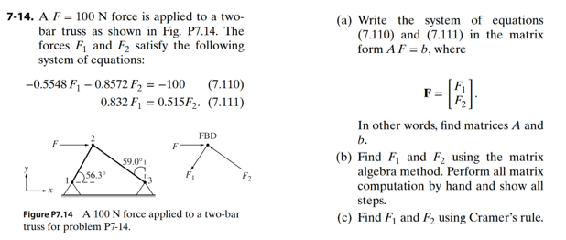

1. Follow the given example in the notes, type the MATLAB program paying close attention to the code because you will need in in the other parts of this problems. ‘Copy & paste’ or take a screen shoot/ picture of the Command Window with your new ‘modified’ MATLAB code and paste it here in this section. Refer to slides for MATLAB code. Write MATLAB code and repeat with t different theta1 and theta2 for each TEST 1 & 3 cases.
2. 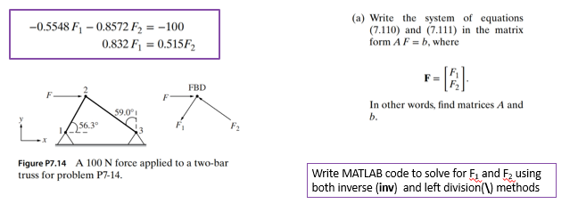**Use the MATLAB example to create MATLAB code for the problem in part A.** Copy & paste’ or take a screen shoot/ picture of the Command Window with your new ‘modified’ MATLAB code and paste it here in this section
3. **Expand the problem on Part B with alternative approach. Write the MATLAB code for your text book problem and add reaction forces.** Copy & paste’ or take a screen shoot/ picture of the Command Window with your new ‘modified’ MATLAB code and paste it here in this section.

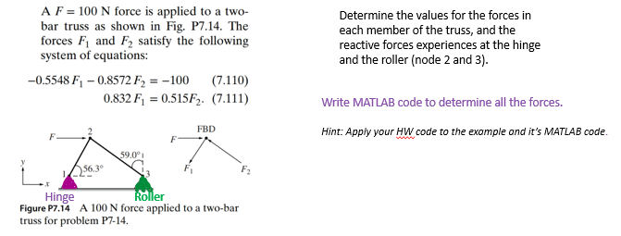

**Part 6. Reflection on** *new* **P3F group ‘collaboration’ activities** 1**0 points**

Write a 2-3 sentence response to the following questions:

1. Who was in your **P3F group** and what 2 points of assistance, feedback, insight, etc. were a subject of discussion to complete this mini-project?
2. Discuss with your **P3F group,** other areas where MATLAB could be a useful STEM tool. Each person must share 1 idea and explain why? (So that makes a minimum of 6 sentences total (or 2 each) and more are not discouraged.

**Format Instructions**: On 1-page (Page #), include the following.

* Heading at top of page🡪 **Part 6. Reflection on P3F group ‘collaboration’ activities - your name**
* **Complete response using subheadings:** 
  + Response a) Members of P3F group & 2 points of discussion
  + Response b) other areas where MATLAB could be a useful STEM tool.